Award-Winning Views at Ski Juwel Alpbachtal Wildschönau
Wiedersberger Horn ranks among Austria's most beautiful winter panoramas!

Snow-covered peaks, sparkling slopes and breathtaking mountain scenery – the panorama from Wiedersberger Horn in the Alpbachtal valley is officially one of Austria's most stunning winter views. At the feratel PanoramaAward 2025/26, the panoramic camera located at the top station of the Hornbahn 2000 lift at the Top of Alpbachtal, the highest point in Ski Juwel Alpbachtal Wildschönau, achieved an outstanding 4th place in the "Winter Wonderland Austria" category. This makes Ski Juwel Alpbachtal Wildschönau the only ski resort in Tyrol to rank among the Top 5.

With almost 14,000 votes cast and 271 panoramic cameras participating from Austria and Switzerland, the feratel PanoramaAward is one of the most prestigious public voting competitions for tourism panorama imagery. The international community voted for destinations that captivate visitors with exceptional views and unforgettable natural scenery.

For many winter sports enthusiasts, the excitement of the next ski day begins long before they arrive in the mountains. A glance at the live panoramic cameras from Ski Juwel Alpbachtal Wildschönau is enough to escape the grey everyday routine. Snow-covered peaks, endless white landscapes and the spectacular mountain scenery of the Kitzbühel Alps awaken the longing for winter. Especially in the early morning hours, when the first rays of sunshine bathe the snowy slopes in golden light, these magical moments inspire the desire for a perfect day in the mountains.

Whether inspiring the next winter holiday or building anticipation for a day on the slopes, the panoramic cameras capture the unique moments that make Ski Juwel Alpbachtal Wildschönau so special. The Top 5 ranking at the feratel PanoramaAward once again demonstrates that this winter wonderland fascinates winter sports enthusiasts far beyond the region's borders.

Discover the Ski Juwel panoramic cameras: www.skijuwel.com/en/webcams

About Ski Juwel Alpbachtal Wildschönau
Ski Juwel Alpbachtal Wildschönau is one of Austria's most popular ski destinations, offering winter sports enthusiasts perfectly groomed slopes, state-of-the-art lifts, breathtaking mountain scenery and cosy alpine huts. With 114 kilometres of pistes, it ranks among the largest ski resorts in Tyrol and provides ideal conditions for families, leisure skiers and ambitious winter sports enthusiasts alike. Renowned as an award-winning family ski resort, Ski Juwel combines authentic alpine charm, modern infrastructure and unforgettable experiences, creating the perfect setting for memorable moments in the snow.

InfoBOX „ski juwel alpbachtal wildschönau“ www.skijuwel.com

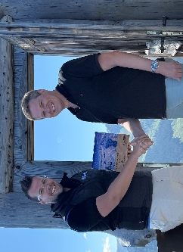
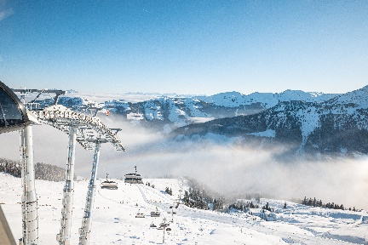
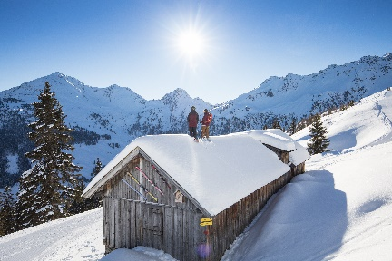
Stefan Leitner, Head of Marketing & Sales at Ski Juwel Alpbachtal Wildschönau, & Peter Schoner, Head of Sales feratel Panorama Austria, during the feratel PanoramaAward presentation at Wiedersberger Horn. . © Ski Juwel Alpbachtal Wildschönau

Surrounded by the breathtaking mountain scenery of Wiedersberger Horn in Ski Juwel Alpbachtal Wildschönau. © Ski Juwel Alpbachtal Wildschönau

Panoramic views across the Kitzbühel Alps from the Top of Alpbachtal – the highest point in Ski Juwel Alpbachtal Wildschönau.
© Ski Juwel Alpbachtal Wildschönau

Press contact
Ski Juwel Alpbachtal Wildschönau
Alpbach 311, 6236 Alpbach

Stefan Leitner Lisa Ainberger, MA
Head of Marketing & Sales Marketing & PR

Mobil: +43 664 8865 3249
Tel.: +43 5336 5233 609 Tel.: +43 5336 5233 641
stefan.leitner@skijuwel.com lisa.ainberger@skijuwel.com
www.skijuwel.com/presse www.skijuwel.com/presse

