**A shower of gold for Ski Juwel Alpbachtal Wildschönau**

**Ski Juwel Alpbachtal Wildschönau has celebrated an outstanding triumph at the International Skiareatest 2025, securing an exclusive title along with five additional trophies. The resort was named Austria’s “Rising Star of the Year” and honoured with a total of six awards.**

For more than three decades, the Skiareatest has been recognised as one of the strictest quality seals in Alpine tourism. Each year, over 220 anonymous testers visit ski resorts across Europe, evaluating pistes, safety, service, infrastructure, gastronomy, and family facilities.

The “Rising Star of the Year” award highlights ski areas that have achieved particularly strong progress in terms of quality and services in recent years. Here, Ski Juwel Alpbachtal Wildschönau stood out. In recent seasons, the resort has further developed its family offerings, enhanced service quality, and invested in modern infrastructure, particularly in snow reliability.

In addition, the ski area received five further awards, including trophies for Friendly Lift Staff, Best Piste Team, the Piste Grooming Trophy, the Marketing Trophy, and the International Piste Quality Seal in Triple Gold.

“This award shows that our strategy of consistently developing service and quality is the right one,” emphasised Reinhard Wieser, Managing Director of the Alpbacher Bergbahn Cable Car Company. “Especially in such a competitive market, this is a strong signal for both our visitors and our employees.”

Ludwig Schäffer, Managing Director of the Wildschönauer Bergbahnen Cable Car Company, underlined the role of staff: “We are particularly proud that this recognition is not only for the pistes, but for the overall development of our ski area. It is an acknowledgement of the work of everyone who helps shape Ski Juwel day after day.”

With 114 kilometres of pistes, 45 lifts, and a wide range of facilities from children’s areas to fun parks, Ski Juwel Alpbachtal Wildschönau ranks among the largest ski resorts in Tyrol. Guests can enjoy 25 mountain huts offering culinary variety, as well as toboggan runs and the Alpine Coaster “Alpbachtaler Lauser-Sauser” for fun away from the pistes. The award ceremony took place on 26 September 2025 in Kitzbühel.

**Awards for Ski Juwel Alpbachtal Wildschönau 2025:**

* Rising Star of the Year (Gold, exclusive)
* Friendly Lift Staff (Gold)
* Best Piste Team (Gold)
* Piste Grooming Trophy (Gold)
* Marketing Trophy (Gold)
* International Piste Quality Seal (Triple Gold)

Further information: www.skijuwel.com

DETAILS „ski juwel alpbachtal wildschönau“ www.skijuwel.com

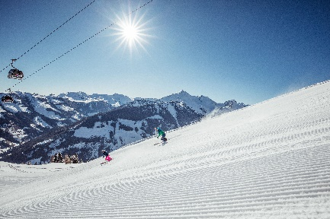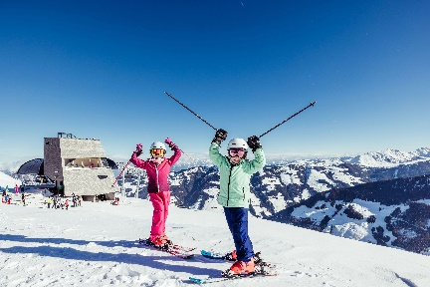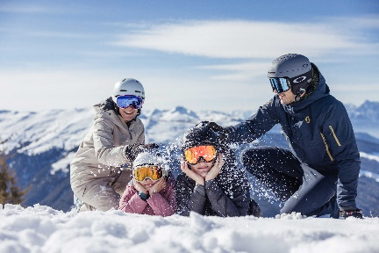

With 114 kilometres of pistes, 45 lifts and numerous attractions, Ski Juwel Alpbachtal Wildschönau is one of the most family-friendly ski areas in Tyrol.

© Ski Juwel Alpbachtal Wildschönau

Reason to celebrate: Ski Juwel Alpbachtal Wildschönau is Austria's “Rising Star of the Year”.

© Ski Juwel Alpbachtal Wildschönau

The excellent slope preparation and slope quality have been awarded the International Slope Quality Seal.

© Ski Juwel Alpbachtal Wildschönau

**­­­­­­­­­­­**

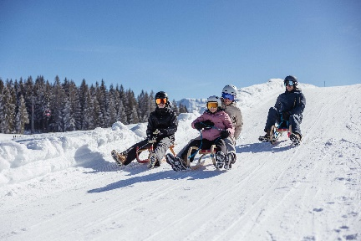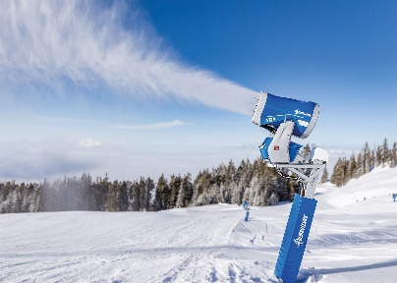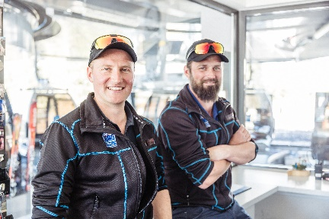

There are also a wide range of activities for the whole family away from the slopes.

© Ski Juwel Alpbachtal Wildschönau

The cable car companies are also proud of the award for its friendly railway staff and piste team.

© Ski Juwel Alpbachtal Wildschönau

Over the past two years, significant investments have been made to ensure snow reliability.

© Demaclenko

**Contact details**

**Ski Juwel Alpbachtal Wildschönau** 2.501 characters

Alpbach 311, 6236 Alpbach Reprint free of charge, specimen copy requested

Stefan Leitner Lisa Ainberger, MA

Head of Marketing & Sales Marketing & PR

Mobile: +43 664 8865 3249

Tel.: +43 5336 5233 609 Tel.: +43 5336 5233 641

[stefan.leitner@skijuwel.com](mailto:stefan.leitner@skijuwel.com) [lisa.ainberger@skijuwel.com](mailto:lisa.ainberger@skijuwel.com)

[www.skijuwel.com/presse](http://www.skijuwel.com/presse) [www.skijuwel.com/presse](http://www.skijuwel.com/presse)

Download more pictures via <https://www.skijuwel.com/Sujetbilder_winter>

© Ski Juwel Alpbachtal Wildschönau