SUN SKI – VIBES ONLY
Sun Skiing & Event Highlights until 12 April 2026
It is that special time of year when winter reveals its most beautiful side: the sun climbs higher in the sky, the peaks glow in the clear light and skiers carve sweeping turns across perfectly groomed pistes. At Ski Juwel Alpbachtal Wildschönau, the atmospheric highlight of the sun skiing season begins now and continues until 12 April 2026. Here, sporting variety, living Tyrolean tradition and an energetic programme of events combine to give late winter a vibrant boost.

The first track is yours – pure First Line feeling!
As the first rays of sunshine touch the summits and the pistes glisten untouched in the morning light, the moment belongs to the early risers. From 7 March 2026, First Line Skiing invites winter sports enthusiasts to experience this magical start to the day every Saturday from 7.00 am. Be among the first to carve fresh tracks into newly groomed slopes, surrounded by tranquillity, open space and the exhilarating feeling of being on top of the world – an exclusive start to the day at the Wiedersberger Horn in the Alpbachtal.

25 mountain huts – 25 times the Tyrolean way of life
Sun skiing is also about indulgence. Across 25 mountain huts, guests are welcomed with regional specialities, warm hospitality and panoramic views that linger longer than any sun-kissed glow. From traditional Tyrolean cuisine to refined local delicacies, a stop for refreshments becomes an essential part of the perfect ski day.

EVENT HIGHLIGHTS AND PURE SUNSHINE!

Kronehit BergBeats – 7 March 2026
Kronehit BergBeats transforms the slopes into an open-air party zone. DJ sounds, sunshine and an exuberant atmosphere create true “Sun Ski Vibes Only” high above the Inn Valley – at Top of Alpbachtal, the highest point in the Ski Juwel Alpbachtal Wildschönau.

Lions Snow Festival – 14 March 2026
Tradition meets celebration at the Lions Snow Festival. Live music, culinary delights and a strong sense of community take centre stage – celebrating for a good cause in an alpine setting at the top station of the Schatzbergbahn cable car in Wildschönau.

Sound on Snow – Winter Finale
20–22 March 2026 & 27–29 March 2026
One of the season’s major highlights is Sound on Snow in Wildschönau. Over two weekends, the mountains provide a spectacular backdrop as international acts, DJs and live bands create a true festival atmosphere in the snow – on the slopes by day, on sunny terraces in the afternoon and during shared celebrations into the evening.

Open-Air Concert with ABBORN – 28 March 2026
The musical highlight of the season is the open-air concert featuring ABBORN. Expect captivating hits, goosebump moments and a mountain panorama that rivals any stage backdrop.

Open Faces Alpbachtal – 4 April 2026
At Open Faces Alpbachtal, international freeriders showcase impressive lines and spectacular runs on the Wiedersberger Horn. An event that combines action, adrenaline and authentic alpine lifestyle.

Family Easter Bonus – Experience more together
During the Easter period, Ski Juwel becomes a true family hotspot. From 14 March 2026 until the end of the season on 12 April 2026, all children up to the age of 15 ski free of charge when at least one parent purchases a ski pass for a minimum of three days. A strong commitment to quality family time in the snow. Creating unforgettable family moments on the slopes. More holiday,less traffic.

More from your holiday – thanks to congestion-free travel
Another key advantage is the quick and hassle-free journey. Ski Juwel Alpbachtal Wildschönau is easily accessible via the Inntal motorway (A12), without long traffic jams or delays. From the Kramsach or Wörgl exits, it is just a few minutes to reach 114 kilometres of pistes. International guests benefit from rail connections to Wörgl or Brixlegg with direct onward links to the ski area, as well as nearby airports in Innsbruck, Munich and Salzburg. The mountain experience begins stress-free – and ends with relaxed turns on sun-drenched slopes.

About Ski Juwel Alpbachtal Wildschönau
Ski Juwel Alpbachtal Wildschönau is one of Austria’s most popular ski regions, delighting winter sports enthusiasts with its wide range of perfectly groomed pistes, modern lifts, breathtaking panoramas and welcoming mountain huts. With 114 varied kilometres of slopes, it ranks among Tyrol’s largest ski areas and offers ideal conditions for families, leisure skiers and more ambitious winter sports enthusiasts alike. This award-winning family ski region impresses with its authenticity, modern infrastructure and unique experiences – creating memorable moments to be enjoyed together.

InfoBOX „ski juwel alpbachtal wildschönau“ www.skijuwel.com

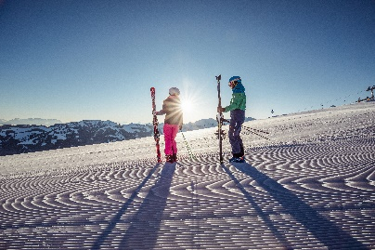
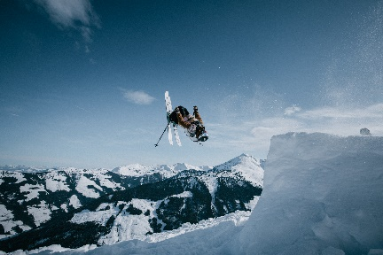


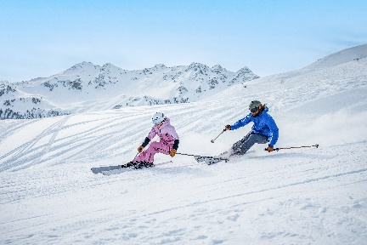
One of the musical highlights on the mountain – the concert by ABBORN on Saturday, 28 March 2026.
© ABBORN
The Open Faces Freeride Series stops at the Wiedersberger Horn in the Alpbachtal on 4 April 2026.
© Open Faces / Mia Knoll
Pure skiing pleasure from as early as 7.00 am during First Line Skiing.
© Ski Juwel Alpbachtal Wildschönau
Culinary delights and alpine indulgence at one of 25 mountain huts and restaurants.
© Austrian National Tourist Office /
Christoph Oberschneider
“Sun Ski Vibes Only” at Ski Juwel Alpbachtal Wildschönau until 12 April 2026 inclusive.
© Austrian National Tourist Office /
Christoph Oberschneider
With 114 kilometres of pistes, Ski Juwel Alpbachtal Wildschönau ranks among the largest ski areas in Tyrol.
© Austrian National Tourist Office / Christoph Oberschneider

Press Contact and Media Enquiries
Ski Juwel Alpbachtal Wildschönau 4,466 characters
Alpbach 311, 6236 Alpbach Reproduction free of charge;
we kindly request a copy of the published material.

Stefan Leitner Lisa Ainberger, MA
Head of Marketing & Sales Marketing & PR

Mobil: +43 664 8865 3249
Tel.: +43 5336 5233 609 Tel.: +43 5336 5233 641
stefan.leitner@skijuwel.com lisa.ainberger@skijuwel.com
www.skijuwel.com/presse www.skijuwel.com/presse

Find more images for free download at www.skijuwel.com/sujetbilder_winter
© Ski Juwel Alpbachtal Wildschönau

