**Ski Juwel Alpbachtal Wildschönau invests in quality and comfort**

With 114 kilometres of varied slopes, modern lift facilities and countless highlights, the Ski Juwel Alpbachtal Wildschönau ranks among the most popular ski resorts in Tyrol. To ensure that winter sports enthusiasts can continue to enjoy the best possible conditions in the future, the resort is once again making substantial investments in its infrastructure for the coming winter season – amounting to around € 3 million in total, ranging from enhanced slope quality to innovative access systems.

**Investments in slopes and snow making**

Across the entire ski area, slope quality is being further improved. This also includes the ongoing expansion of the snowmaking facilities, enabling even more efficient and resource-friendly snow production. From the coming winter season, a further 30 snow generators will be in operation in the Alpbachtal, along with 14 new snow generators in the Wildschönau. This brings the ski area closer to its goal of being able to complete the base snow coverage within just three days in the future. The new machines also consume significantly less energy, making an important contribution to the sustainable use of natural resources.

These measures ensure perfect conditions on all runs and increase snow reliability from the beginning to the end of the winter season.

**New access system: Ski pass on your smartphone**

Another innovation concerns access to the lifts: with the new “mobile ticket” technology from SKIDATA, hourly and one-day passes can be loaded directly onto a smartphone. In addition, all access terminals have been completely replaced. Mobile tickets are available in the online shop. Access is then conveniently possible via mobile phone, so a physical data carrier such as a key card or deposit card is no longer strictly necessary.

**New children’s slope at the Schatzberg**

At the Schatzberg, an existing connecting track from the top station of the Schatzbergbahn cable car to the Hahnkopfbahn chairlift will now be used as a new blue slope for children. This creates another attractive option for families and beginners.

**Further improvements for children and beginners**

In the Schatzberg Zwergenland, an additional conveyor belt will be installed. At the top station of the Markbachjochbahn cable car, winter sports enthusiasts will also find a new, 110-metre-long covered conveyor belt – ideal for comfortable ascents and first turns in the snow.

**Event highlights in winter 2025/26**

**Sport & Action**

* Open Faces Freeride Contest on 07 February 2026

**Music & Entertainment**

* Kronehit BergBeats at Wiedersberger Horn on 07 March 2026: a new mountain DJ event
* Sound on Snow: musical season finale with three event weekends
  + 14 March 2026: Snow Festival at the Schatzberg – organised by the LIONS Club
  + 20 - 22 March 2026: Winter Finale Niederau – music programme in cooperation with restaurants on the mountain and in the valley
  + 27 - 29 March 2026: Live acts with stage at the Schatzberg, top act ABBORN on Saturday, supported by local bands on Friday and Sunday, refreshments served directly at the top station

**Ongoing highlights**

* Night skiing at the Reither Kogel from 26 December 2025 to 06 March 2026 (every Thursday and Friday)
* Piste basher co-pilot at the Reither Kogel from 28 December 2025 to 01 March 2026 (every Monday, Wednesday and Sunday)
* First Line Skiing at the Wiedersberger Horn from early March 2026 (every Saturday)

With these innovations and a varied events programme, the Ski Juwel Alpbachtal Wildschönau will once again offer a winter sports experience in the coming season that combines quality, comfort and entertainment.

InfoBOX „ski juwel alpbachtal wildschönau“ www.skijuwel.com

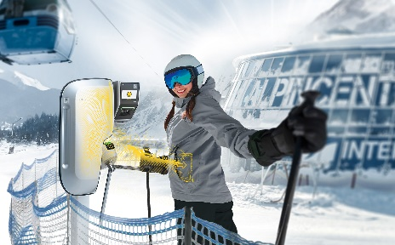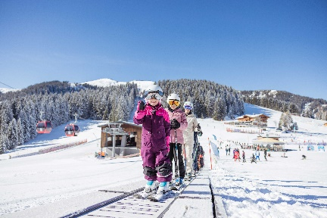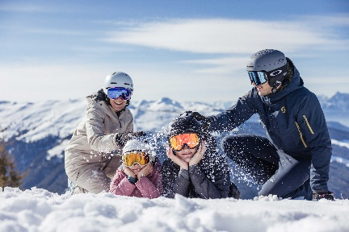

The Ski Juwel Alpbachtal Wildschönau, with 113 kilometres of slopes, 45 lifts and a wealth of highlights, is one of the most family-friendly ski resorts in Tyrol.

© Ski Juwel Alpbachtal Wildschönau

The new conveyor belts provide a comfortable start for those first turns in the snow.

© Ski Juwel Alpbachtal Wildschönau

Simple, fast and contactless: with the mobile ticket, you can head straight through the turnstile and onto the slopes.

© SKIDATA

**­­­­­­­­­­­**

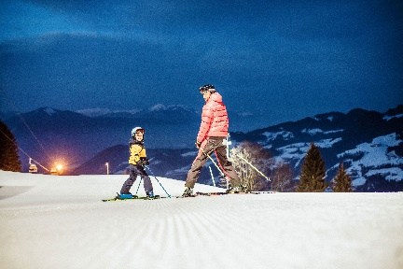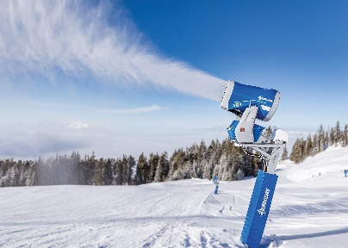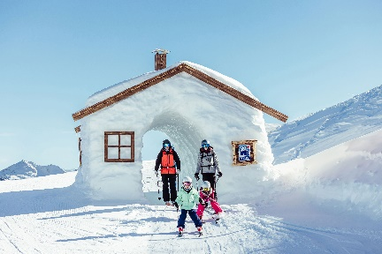

A total of 44 new snow generators ensure even more efficient snowmaking.

© Demaclenko

The numerous and varied attractions make the ski area particularly popular with families.

© Ski Juwel Alpbachtal Wildschönau

This coming winter, a diverse events programme on and off the slopes promises varied and exciting ski days.

© Ski Juwel Alpbachtal Wildschönau

Download more pictures via [www.skijuwel.com/sujetbilder_winter](http://www.skijuwel.com/sujetbilder_winter)

© Ski Juwel Alpbachtal Wildschönau

**Contact details**

**Ski Juwel Alpbachtal Wildschönau** 3.639 characters

Alpbach 311, 6236 Alpbach Reprint free of charge, specimen copy requested

Stefan Leitner Lisa Ainberger, MA

Head of Marketing & Sales Marketing & PR

Mobile: +43 664 8865 3249

Tel.: +43 5336 5233 609 Tel.: +43 5336 5233 641

[stefan.leitner@skijuwel.com](mailto:stefan.leitner@skijuwel.com) [lisa.ainberger@skijuwel.com](mailto:lisa.ainberger@skijuwel.com)

[www.skijuwel.com/press](http://www.skijuwel.com/press) [www.skijuwel.com/press](http://www.skijuwel.com/press)