Ski the slopes. Feel the charm.
Ski Juwel Alpbachtal Wildschönau

Some winter holidays are measured in kilometres. The best ones are measured in moments. First tracks on a quiet morning. Rosy cheeks over lunch in a cosy mountain hut. One last run as the sun dips behind the peaks. And that feeling of having found a place that still feels genuinely personal.

At Ski Juwel Alpbachtal Wildschönau, there is plenty of room for all of it. With 114 kilometres of pistes, 43 lifts and 25 mountain huts, the ski area combines impressive variety with the character and easy-going atmosphere of two authentic Tyrolean valleys: Alpbachtal and Wildschönau. Across four mountains and two valleys, families, leisure skiers and more ambitious winter sports enthusiasts will find space to enjoy winter at their own pace – from days on the slopes to traditional villages, welcoming mountain huts and memorable experiences beyond the pistes.

Plenty of skiing - without losing its character
A winter morning in Ski Juwel Alpbachtal Wildschönau often starts with views of snow-covered wooden houses and farms as the first sunlight reaches the mountains. It is a setting that says much about the character of the ski region. While modern lifts take skiers comfortably into the mountains, life in the valleys below remains closely connected to Tyrolean traditions.

Across 114 kilometres of pistes and 43 lifts , beginners can find gentle terrain for their first turns, families can explore the mountains together and experienced skiers have plenty of runs to discover. Stretching across four mountains and connecting Alpbachtal and Wildschönau, the ski area offers enough variety to fill several days without losing its pleasantly manageable feel.

At 2,030 metres, the Top of Alpbachtal marks the highest point in the ski area. Its distinctive wooden 360-degree viewing tower is clad with handcrafted shingles from Alpbach and opens up panoramic views across the surrounding Tyrolean Alps.
Down in the valleys, both Alpbachtal and Wildschönau have retained much of their original character. Alpbachtal combines traditional villages, distinctive wooden architecture and a landscape shaped by the surrounding mountains, with Alpbach - often referred to as Austria’s most beautiful village – at its heart. Wildschönau is equally rooted in Tyrolean tradition, with historic farmhouses and mountain villages such as Thierbach, the highest village in the Kitzbühel Alps. Together, the two valleys give the ski area its authentic and distinctly Tyrolean character. This connection between skiing, village life and local culture is an important part of what makes a holiday here different.

Made for families – from first turns to new adventures
Family skiing has an important place at Ski Juwel Alpbachtal Wildschönau. The Kinderland Juppi-Do and Schatzberg Zwergenland, together with practice areas across the ski region, provide plenty of opportunities for children to gain confidence on snow.
Once those first turns have been mastered, there is more to discover. Older children and teenagers can head to the Alpbachtal Snowpark and Schatzberg Snowpark, while the Family Park at Wiedersberger Horn combines a Funslope and KidsRun. Skiers can measure their speed at the Speed Check, and the Alpbachtaler Lauser-Sauser, an Alpine Coaster at the Wiedersberger Horn, adds another dose of action to a day in the mountains.

Families visiting towards the end of winter can also benefit from the Family Easter Bonus from 13 March – 04 April 2027 . During the offer period, children up to the age of 15 ski free of charge when at least one parent purchases a ski pass for a minimum of three days.

25 mountain huts and a taste of Tyrolean life
Skiing in Tyrol has always been about more than simply getting from the top of the mountain to the bottom. A stop at a mountain hut is part of the day – and with 25 traditional huts spread across Ski Juwel Alpbachtal Wildschönau, there are plenty to choose from.
Here, regional cuisine and warm hospitality meet panoramic mountain views. Guests might share a Kaiserschmarrn from a giant pan at the Böglalm in Alpbach or try Wildschönau pretzel soup at the Gipfö Hit on Schatzberg. Traditional Tyrolean dishes sit alongside other regional specialities, and on sunny days the terraces become places where a quick lunch can easily turn into a longer break.
This is where the character of the two valleys can perhaps be felt most easily. The emphasis is not on rushing through as many kilometres as possible, but on enjoying the whole ski day: good pistes, mountain scenery, regional food and time together.

Beyond skiing: winter has many sides
With four mountains and two valleys to discover, a winter holiday at Ski Juwel does not have to revolve entirely around skiing.
For a change of pace, visitors can head out on one of the region's natural toboggan runs. The runs at Markbachjoch and Schatzberg in Wildschönau have been awarded the Tyrolean toboggan run quality seal, while the Panoramaweg at Reither Kogel offers another long descent in Alpbachtal.

Those looking for quieter winter moments can explore the snow-covered landscape on winter and snowshoe hikes. Groomed winter walking paths lead through the valleys or on the mountains. On the Markbachjoch, the cosy huts and a picturesque chapel are surpassed by the beautiful panoramic view of the Wildschönau valley. Families discover the winter version of Juppi Zauberwald, a family-friendly winter walking trail in Alpbachtal. Torchlit walks in the evening offer yet another perspective on the mountains. Guided walks and snow shoes are included in the guest cards.
A horse-drawn carriage ride through the authentic mountain villages provides perhaps the most traditional way to experience the winter landscape: the sound of hooves and runners on the snow, traditional farms along the way and the mountains rising around the valley.

There are more unusual experiences too. In Wildschönau families and groups have fun at Roggenboden night tobogganing on special sleds, while in Alpbachtal guests can experience what it feels like to ride as a co-pilot in a piste basher.

And the ski day does not necessarily end when the sun goes down. Night skiing in Alpbachtal from 25 December 2026 - 05 March 2027 gives skiers the chance to make turns under floodlights, while evening winter activities add another dimension to a holiday in the two valleys.

Spring sunshine and first tracks of the day
As the winter season moves towards spring, Ski Juwel takes on a different atmosphere. The sun climbs higher above the mountains, mornings begin with crisp pistes and afternoons invite longer stops on the terraces.
Early risers can make the most of these conditions with First Line Skiing from 05 March till 03 April 2027. From 7.00 am, skiers can head up the Wiedersberger Horn in Alpbach and enjoy freshly groomed pistes in the quiet of the early morning – with the first sunlight reaching the surrounding peaks.
Later in the day, the 25 mountain huts become part of the sun-skiing experience, combining regional food with panoramic terraces and a relaxed end to a day on the slopes.
Skiing continues until 04 April 2027, making the later part of the season an attractive time for families, leisure skiers and anyone who likes to combine turns on the mountain with spring sunshine.

Events on the mountain
Sport, music and entertainment complement the skiing throughout the season.
The programme begins on a more traditional note with the Mountain Advent in Alpbachtal on 20 December 2026, bringing a touch of Tyrolean Christmas atmosphere to the mountain.

For those who prefer action on the mountain, Open Faces Alpbachtal on 06 February 2027 brings international freeriders to the Wiedersberger Horn, showcasing demanding lines against the backdrop of the Tyrolean Alps.
In Wildschönau the Sound on Snow Festival in March brings a festival atmosphere with DJs, live bands and performances on the mountain. One of the musical highlights is an open-air concert with a Beatles-Coverband on 20 March 2027 at Schatzberg. Throughout the season the weekly events "Winter Night" in Niederau & the Drachental family afternoon are a perfect end of the skiing day.

Together with other recurring winter experiences, the programme offers plenty of reasons to discover another side of Ski Juwel Alpbachtal Wildschönau beyond a classic day on the pistes.

Still real: two valleys, one ski experience
What ultimately distinguishes Ski Juwel Alpbachtal Wildschönau is the combination of contrasts. It is large enough to offer 114 kilometres of ski pistes and a great variety, while its charm is still noticeable. It has modern lifts, yet its villages remain shaped by wooden houses, traditional farms and family-run businesses. There are snowparks and action for younger guests, but also horse-drawn carriage rides, winter walks and quiet mountain huts.

Alpbachtal and Wildschönau have their own identities, landscapes and traditions. Together, they create a ski region where guests can spend the day exploring the mountains without losing that connection to the places below.
It is not about looking back. It is about preserving what matters while making a winter holiday comfortable for today.

Ski the slopes. Feel the charm. And experience a part of Tyrol that is still real.

Ski Juwel Alpbachtal Wildschönau at a glance
114 km of pistes | 43 lifts | 25 mountain huts | four mountains | two valleys | dedicated children's areas | Snowparks | Family Parks | Top of Alpbachtal at 2,030 m | Alpine Coaster Alpbachtaler Lauser-Sauser | natural toboggan runs | winter & snowshoe hiking | night skiing & night tobogganing | First Line Skiing | Snow Events & much more to discover!

Winter season from 04 December 2026 – 04 April 2027
Family Easter Bonus from 13 March till season end

InfoBOX „ski juwel alpbachtal wildschönau“ www.skijuwel.com

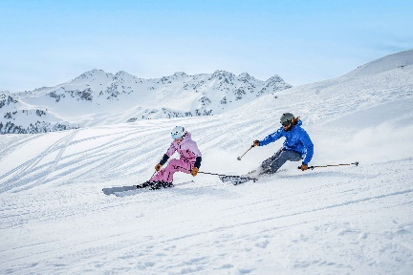
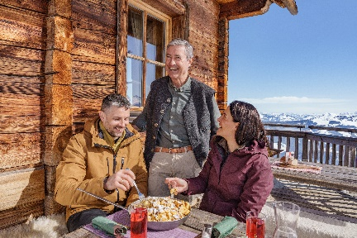
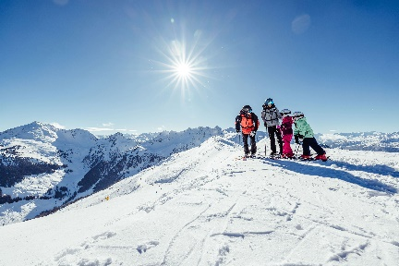
25 rustic huts treat you to a variety of Tyrolean specialities and regional delicacies. © Austria Tourism / Christoph Oberschneider
The diverse range of long and wide pistes ensures unique skiing pleasure in the heart of Tyrol. © Ski Juwel Alpbachtal Wildschönau
With 114 kilometres of pistes, 43 lifts and numerous attractions, Ski Juwel Alpbachtal Wildschönau is one of the most family-friendly ski areas in Tyrol.
© Ski Juwel Alpbachtal Wildschönau

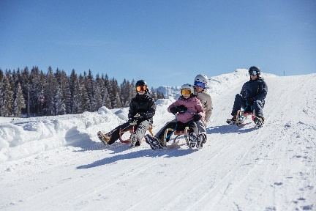
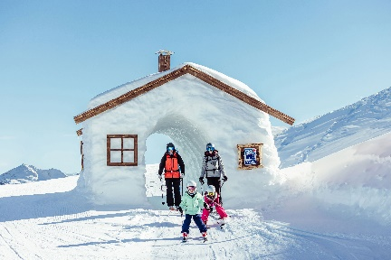
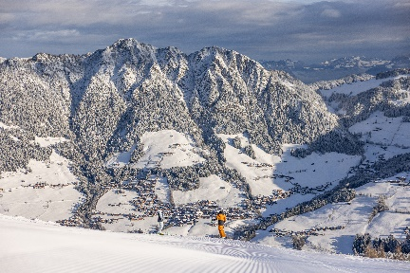
The numerous, multi-faceted attractions make the ski area particularly popular with families.
© Ski Juwel Alpbachtal Wildschönau

Ski the view - at Ski Juwel Alpbachtal Wildschönau! © Ski Juwel Alpbachtal Wildschönau

Off-piste, a toboggan run with the whole family guarantees an unforgettable experience in the snow.
© Ski Juwel Alpbachtal Wildschönau

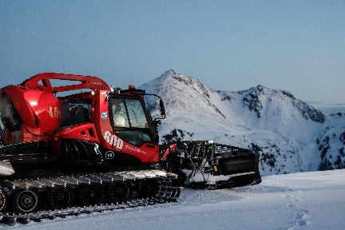
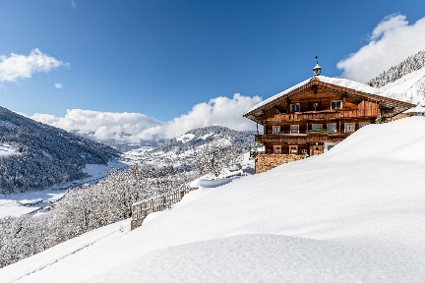
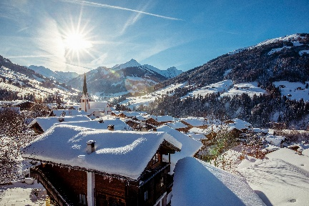
Ski the slopes. Feel the charm – Between landscpaes and traditions.
© Alpbachtal Tourismus

Be our co-pilot on the big snow bashers machines on the snow.
© Ski Juwel Alpbachtal Wildschönau
The impressive, deeply snow-covered landscape in the heart of Tyrol invites you to go winter hiking and relax.
© Wildschönau Tourismus

Download more pictures via www.skijuwel.com/sujetbilder_winter
© Ski Juwel Alpbachtal Wildschönau

Contact details
Ski Juwel Alpbachtal Wildschönau 9.816 characters
Alpbach 311, 6236 Alpbach Reprint free of charge, specimen copy requested

Stefan Leitner Lisa Ainberger, MA
Head of Marketing & Sales Marketing & PR

Mobile: +43 664 8865 3249
Tel.: +43 5336 5233 609 Tel.: +43 5336 5233 641
stefan.leitner@skijuwel.com lisa.ainberger@skijuwel.com
www.skijuwel.com/press www.skijuwel.com/press

